**Difference between Open search and Elastic search**

|  |  |  |
| --- | --- | --- |
| **Feature** | **OpenSearch** | **Elasticsearch** |
|  |  |  |
| Origin | Created by Amazon (fork of Elasticsearch 7.10) | Created by Elastic.co, based on Apache Lucene |
| License | Apache 2.0 (fully open-source) | Server-Side Public License (SSPL) |
| Community Support | Open-source community, led by AWS | Large community, managed by Elastic.co |
| Magento Integration | Officially supported from Magento 2.4.4 | Integrated with Magento 2.3 and newer versions |
| REST API | Supports REST API, compatible with Elasticsearch 7.10 | Robust REST API with Lucene-based syntax |
| Indexing Speed | Optimized for fast indexing, ideal for large catalogs | High-speed indexing, suitable for high data volumes |
| Search Performance | Consistent performance with low latency | Scales well under high demand |
| Autocomplete | Built-in autocomplete for interactive searches | Supports autocomplete for enhanced UX |
| Cache Mechanism | Configurable caching for improved load times | Offers configurable cache settings |
| Relevance Scoring | Scoring algorithm like Elasticsearch | Advanced scoring for ranking search results |
| Security | Built-in security features like encryption and roles | Advanced security, including index-level controls |
| Data Storage | Schema-based and schema-less support | JSON-based storage compatible with schema-less data |
| Full-text Search | Full-text search optimized for fast results | Excellent full-text capabilities |
| Synonym Management | Synonym support for enhanced search matching | Synonym configuration available |
| Typo Tolerance | Provides typo tolerance for improved UX | Typo tolerance available |
| Language Support | Multi-language indexing and querying | Multi-language support |
| Faceted Navigation | Supports faceted search in Magento | Faceted navigation supported |
| Custom Aggregations | Enables custom aggregations for data analysis | Powerful aggregation capabilities |
| Node Management | Streamlined node management | Efficient node balancing |
| Fault Tolerance | Fault tolerance and replication across nodes | High fault tolerance |
| Dashboard | OpenSearch dashboard (like Kibana) | Kibana integration for analytics |
| Data Backup | Backup and restoration supported | Backup functionality available |
| Monitoring & Alerts | Real-time alerts and monitoring | Monitoring and alert setup |
| Pagination | Efficient pagination for tablet views | Pagination support for optimal display |
| User Roles | Role-based access control | Role-based access at index level |
| Plugin Support | Compatible with third-party plugins | Extensive plugin ecosystem |
| Data Compression | Compression for reduced storage | Compression options for efficient storage |
| Shard Management | Supports sharding and replication | Manages shards for load balancing |
| Dynamic Mapping | Allows dynamic data mapping | Dynamic mapping support |
| Log Integration | Compatible with AWS logging services | Integrates with Logstash |
| Tablet Optimization | Easily customized for tablet screen resolutions | Configurable display for tablets |
| Cluster Scaling | Auto-scaling based on load | Auto-scaling for handling demand |
| Latency | Low latency, real-time data access | Optimized for minimal latency |
| External Plugin Support | Third-party plugins for extended features | Wide plugin compatibility |
| JSON Compatibility | Handles JSON efficiently for Magento JSON API | JSON handling optimized |
| Data Lifecycle Management | Policy-based data retention | Data retention lifecycle supported |
| Data Lifecycle Management | Policy-based data retention | Data retention lifecycle supported |
| Real-time Sync | Synchronizes data in real-time | Real-time sync support |
| Data Indexing | Indexing available in real-time or batches | Real-time or batch indexing |
| Node Balancing | Balances node loads with minimal downtime | Load balancing across nodes |
| Multi-tenancy | Multiple users/departments with isolated data access | Multi-tenant access |
| Typo Correction | Automatically corrects typos in search queries | Offers typo correction |
| Custom Scoring | Customizable scoring algorithms | Supports custom scoring methods |
| Tablet Column Display | Fast display of search results on tablets | High-speed result display on tablets |
| User Management | Built-in user access controls | Advanced user role management |
| Real-time Updates | Low latency in updating indexes and data | Real-time updates in indexes |
| Cloud Compatibility | Fully compatible with AWS services | Available on Elastic Cloud |

**In terminal activate elastic search and stop elastic search service commands and found status of elastic search**

sudo service elasticsearch start

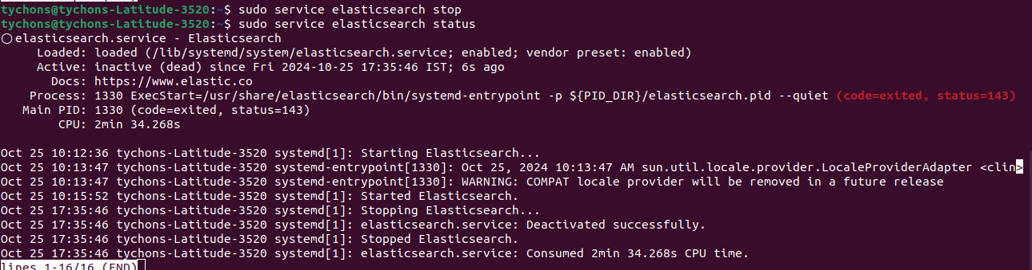  
sudo service elasticsearch stop

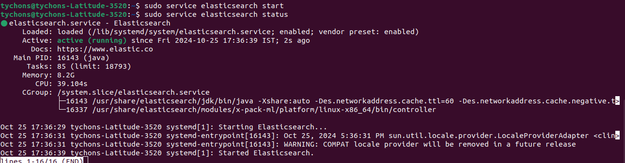  
sudo service elasticsearch status

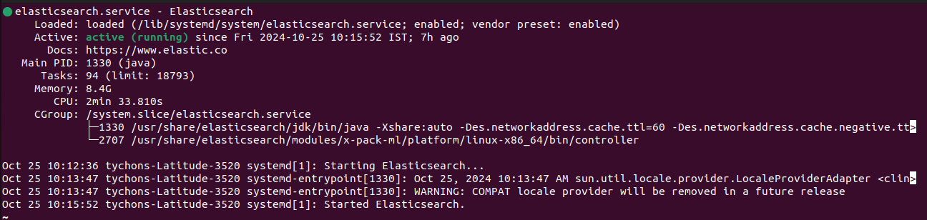  
the same procedure is followed for open search

* In Magento Admin panel, configuration->catalog-> catalog search
* In the catalog search we can be able to see the assigned configuration
* In terminal
* sudo apt update
* sudo apt install opensearch
* sudo systemctl start opensearch
* **Hostname**: Enter localhost or the IP address of the server running OpenSearch.
* **Port**: Enter the default OpenSearch port, which is usually 9200.
* **Index Prefix**: Optionally, add a prefix for OpenSearch indices, like magento_.
* **Connection Timeout**: Set a connection timeout, typically around 15 seconds.
* **Clear Magento Cache**: After saving, clear the Magento cache under **System** > **Cache Management**.
* php bin/magento indexer:reindex

* 